Resume of Dr. Udaykumar Virupaxappa Kokatnur, M.E., Ph.D.
Udaykumar Virupaxappa Kokatnur is having experience in academics, use of ICT tools, adding to learning enhancement, mentoring of students and committed to the profession in academics.
1. Personal Information
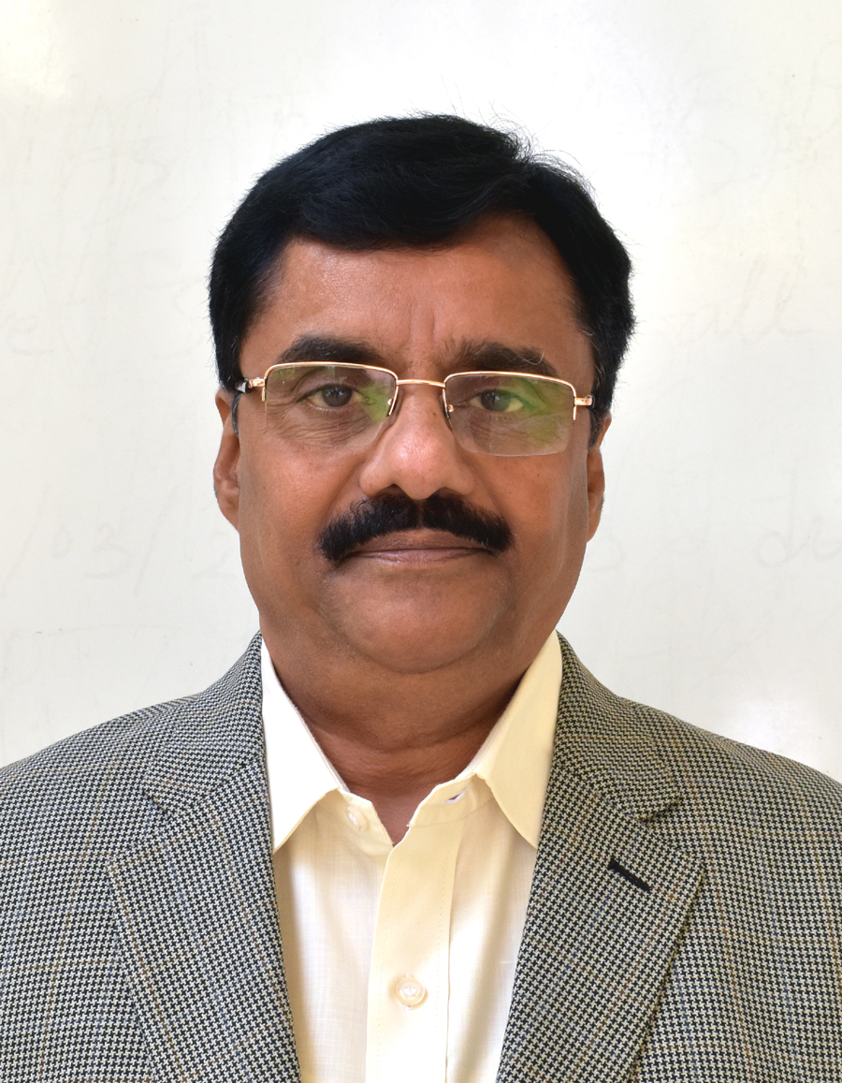
a) Name : Dr. Udaykumar Virupaxappa Kokatnur
b) Date of Birth : 07/08/1961
c) Sex : Male
d) Passport No. : P6583331 Validity: 22/12/2026
e) Address Present : No. 247, EWS, 4th Main, 1st Stage, KHB Colony, Basaveshwar Nagar, Bangalore-560079
Karnataka State, India.
Permanent : LIG-183, Mahantesh Nagar
Belagavi, Karnataka, 590016, India.
f) Mobile : +91 9448431978 / 9916131978 Email: udaykok7861@gmail.com
g) Income Tax PAN No. : ADYPK8709P Aadhaar : 307273477194
h) Proficient in :
- Computer Aided Engineering Drawing,
- Computer Aided Machine Drawing,
- Computer Aided Equipment Drawing
- Engineering Graphics
- Theory of Plasticity,
- Metal Forming,
- Theory of Elasticity,
- Industrial design and Ergonomics,
- Work study and Ergonomics,
- Project Management,
- Industrial Engineering,
- Production Management,
- Operations Management,
- Total Quality Management
- Research Methodology & Intellectual Property Rights
2. Professional memberships
Sl.No. | Institution/Organization | Nature of Licence
1. | Indian Society for Technical Education (ISTE) | Life Member, LM 20002
2. | Association for Machines and Mechanics, IIT, Chennai | Life Member, LM 163
3. Academic Background
Degree | University | Year | Specialization | Class/Division
Ph.D. | Visvesvaraya Technological University, Belagavi | Feb. 2019 | Mechanical Engineering Science
M.E. | Karnataka University, Dharwad | 1992 | Production Management | I Class(61.4%)
D.T.D.D | NTTF, Dharwad | 1988 | Tool Design and Drawing | Pass
B.E. | Karnataka University, Dharwad | 1984 | Mechanical Engineering | I Class(65.8%)
4. Projects/ Thesis Undertaken at Undergraduate/Postgraduate/Doctorate Level
Undergraduate (B. E.) : Electronic Ignition system for four Wheeler
Postgraduate (M. E.) : Computerized Line Balancing
Doctorate (Ph. D.) : Quality Assessment of Health Care Services in Primary Health Care Centers
5. Domain Knowledge in Software
i) Solid Edge, ii) Solid works, iii) Catia V5, iv) SPSS V20, v) Corel Draw and vi) Photoshop
6. Employment Record
Sl. No. | Institution / Industry | Year | Duration | Designation
 | S. R. Malikopmath Engineering Works, Gadag, Karnataka, India | 01-07-1984 to 21-09-1985 | 1 Year 2 months | Production Supervisor
 | Rural Engineering College, Hulkoti, Dist. Gadag, Karnataka, India | 22-09-1985 to 14-11-1992 | 7 Years 2 months | Lecturer
 | K L E Dr. M. S. Sheshgiri College of Engineering and Technology, Belagavi, Karnataka, India | 16-11-1992 to 31-03-1999 | 26 Years 9 Months | Lecturer
 |  | 01-04-1999 to 31-03-2004 | 26 Years 9 Months | Senior Lecturer
 |  | 01-04-2004 to 31-03-2010 | 26 Years 9 Months | Assistant Professor
 |  | 01-04-2010 to 31-05-2013 | 26 Years 9 Months | Associate Professor
 |  | 01-06-2013 to 31-07-2014 | 26 Years 9 Months | Associate Professor and Head of Department
 |  | 01-08-2014 to 31-08-2019 | 26 Years 9 Months | Associate Professor
 | Sambhram Institute of Technology, Bengaluru | 18-10-2019 to 30-10-2020 | 1 Year | Professor, Mechanical Engineering
 | Shree Dhanvantary College of Engineering and Technology, Kim, Surat, Gujarat | 27-11-2020 to 26-11-2021 | 1 Year | Principal
 | VSM's Somashekhar R Kothiwale Institute of Technology, Nipani, Karnataka | 01-12-2021 to 30-12-2023 | 2 Years | Professor and Consultant AICTE
- Achievements: Trained 900 staff members of Karnataka state engineering colleges in Solid edge software to draw 2D and 3D modeling to introduce Computer Aided Engineering Drawing and Computer Aided Machine Drawing for the faculty of colleges affiliated to Visvesvaraya Technological University, Belagavi.
Took approval from AICTE and affiliation from Gujarat Technology University to start 3 undergraduate courses in Shree Dhanvantary College of Engineering and Technology, Kim, Surat, Gujarat in 2021 and changed name of the college from Diploma to Engineering.
Last year I have taken an approval from AICTE and University to start UG and Diploma courses in Engineering and Polytechnic Colleges and increased intake and admissions.
- Guest lecturer
- Visvesvaraya Technological University, Belagavi, M.tech. (Product design & Manufacturing), Industrial design and Ergonomics.
- Visvesvaraya Technological University, Belagavi, M.B.A., Production and Operations management.
- Lingaraj College of Business Administration, Belagavi, B.B.A, Production and Operations management.
9. Publications
A. Co-Author of Books
1. A Primer on “Computer Aided Engineering Drawing” For I / II Sem. BE. Published by Visvesvaraya Technological University, Belagavi, Karnataka.
2. Question Bank with Solutions on “Computer Aided Engineering Drawing” for I / II Sem. BE. Published by Visvesvaraya Technological University, Belagavi, Karnataka.
3. A Primer on “Computer Aided Machine Drawing” for III Sem. BE (ME, AU, IP, IM). Published by Visvesvaraya Technological University, Belagavi, Karnataka.
4. Computer Aided Engineering Drawing for I / II Sem. BE/BTech., Published by CBS Publisher & Distributers Pvt. Ltd., New Delhi, India.
B. Refereed International Journal Publications
- Uday V. Kokatnur, S. R. Bharamanaikar, Dr. Shivaprasad S. Goudar, Rajashekar Patil. “A frame work for quality assessment using critical factors of the primary health care: a case of rural area in north Karnataka”, International Journal of Engineering Research and Development, Volume 5, Issue 8, Jan., 2012, PP. 19-26.
- Uday Kokatnur, Havinal Veerabhadrappa, Sirigeri Jayanna, ”Relation Between Zone of Tolerance And Importance of Service Quality Attributes: An Empirical Study Commercial Banks", Asia Pacific Journal of Marketing & Management, pp 92-106, ISSN 2319-2836, Vol.2 (7), July 2013.
- Uday Kokatnur “Technological Status and Upgradation of SMES”, Journal of Advances and Scholarly Researches in Allied Education, Vol.-VIII, Issue-XV, July 2014.
- Udaykumar V. Kokatnur, Sharanabasava C. Pilli, “Assessment of Total Quality of Health Care in Rural Primary Health Centers”, The IUP Journal of Operations Management, XVII (2), 2018, pp. 29-56.
- Udaykumar V. Kokatnur, Sharanabasava C. Pilli, “The Quality of Health Care Delivery in Primary Health Centers under Public Private Participation”, The IUP Journal of Operations Management, Vol. XVII (4), 2018, pp. 7-26.
C. International Conference Publications:
1. 16th to 18th January, 2004, International Conference Sponsored by UGC & NAAC, at Ethiraj College for Women, chennai, Topic : “Outbound Training : An Effective Learning System”.
2. 6th to 7th April 2019, 20th International Conference on Contemporary Issues in Science, Engineering and Management, Singapore, Topic: “Quality of Health Care in Primary Health Centers: A Comparative Study of Centers Managed by Health Department and Public Private Partnership”.
D. National Conference/ Symposium/Workshop Publications:
1. 3rd to 4th Nov., 2001 IV Karnataka State ISTE Convention held at Basveshwar Engineering College, Bagalkot, Topic : “Train The Trainer – Need For Engineering faculty”,
2. 27th to 30th Dec., 2003 National Seminar on “Reaching the Unreached: A Challenge to Technical Education” in XXXIII ISTE Convention held at Kumaraguru College of Technology, Coimbatore Topic : “Ingredients For Total Quality in Engineering Education”.
3. 21st to 22nd May, 2004, National Conference on “Modern Trends in Management” Sponsored by VTU, Belagavi at Gogte Institute of Technology, Belagavi, Topic : “Supplier Selection Module”.

- Resource Person for
- One-Day Workshop: Entrepreneurship Development Programme. Maratha Mandal Polytechnic Belagavi, 2004.
- One-Day Workshop: Entrepreneurship Development Programme. Bhatatesh Polytechnic, Belagavi.
- Three-Day Workshop: Train The Trainer Programme on CAED, SIT, Tumkur, 2006.
- Three-Day Workshop: Train The Trainer Programme on CAED, BMS, Bengaluru, 2006.
- Three-Day Workshop: Train The Trainer Programme on CAED, STJIT, Ranebennur, 2006.
- Three-Day Workshop: Train The Trainer Programme on CAED, PES, Mandya, 2006.
- Three-Day each Workshop: Train The Trainer Programme on CAMD, Organised by VTU, Belagavi conducted at STJIT, Ranebennur, Global Academy, Bengaluru REVA, Bengaluru, SJCE, Mysore, 2007.
- Three-Day Training Programme on CAMD, Organised by Bengaluru Institute of Technology, Bengaluru, 28th - 30th July, 2008.
- Four-Day Workshop on CAED and CAMD using Smart Board, Organised by SIT, Tumkur, 01st – 04th Aug., 2008.
- Three-Day Workshop on “Computer Aided Process Equipment Drawing”, Organised by KLE Dr. MSS College of Engineering and Technology, Belagavi, 29th – 31st July, 2011.
- Faculty Development Programme on “CAED, CAMD”, 01st - 06th July, 2016, Organised by Atria Institute of Technology, Bengaluru in association with Siemens.

- Professional Development-Workshops/Short Term Training Programs Attended
Course | Type | Attended
Conferences/Seminars | International | 01
Conferences/Seminars | National | 07
Training/Courses | STTPs | 03
Training/Courses | FDPs | 08
Training/Courses | Workshops | 15
Activity Organized | Conferences | 01
Activity Organized | Seminars | 06
Activity Organized | FDPs | 06
Activity Organized | Workshops | 05

- Invited Talks Delivered: 09

- Secretary of ISTE Local Chapter for 12 years organised many Workshops, Conferences, Seminars and Faculty Development Programs.

- ISO Internal Auditor for 3 years 2016 to 2019.

- NBA Coordinator for 3 years 2016 to 2019.
- IQAC Co-ordinator for 4 years 2019 to 2023.

- Member, Board of Examination, BVB College of Engineering and Technology Autonomous College, Hubbali, 2007.

- Chairman / Member, Board of Examination, Visvesvaraya Technological University, Belagavi, 2020.
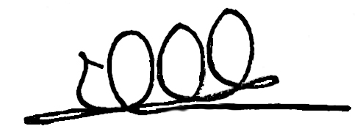
Udaykumar V. Kokatnur

